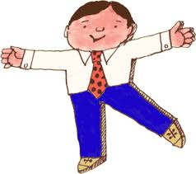
Flat Stanley Project 2024:
Due Date: May 13th

We have started a fun project using each student’s personally created “Flat Stanleys”. This type of project has stemmed from the Flat Stanley stories. Each student will be taking his or her Stanley on outings and taking pictures of him (or her) around Seattle and beyond!

For instance, if you are taking a trip down to Alki Beach, bring Stanley and take a picture of him building a sand castle or ordering fish and chips…
Stanley is small and portable, so he can go anywhere. Maybe he will go to work with his owner’s parents. To a movie, sporting event, shopping day, coffee shop…you name it. The students should have two laminated flat people, so maybe one can be in the car in case a fun picture opportunity pops up.

Stanley will need to keep a journal of his outings. This journal will come home prior to spring break. The journal will be written from the flat person’s point of view. He/she will describe what is happening in the outing. Try to include any facts about the place that is being visited---like: “The Denny party landed right here at Alki Beach in November of 1851” Each entry should have one or more pictures to accompany the journal entry.
The goal is to complete at least 3-4 quality final draft entries at home between March 29th and May 13th with pictures. Students are welcome to do more however. There are extra pages in the book. We will complete three additional entries at school. One before sending the journal home, one after spring break and a final one after the students turn them in in May. So total entries will be at least 6-7, counting the 3 or 4 done at home.

Journal entries must be neatly and thoughtfully completed. A well-written paragraph that includes a topic sentence, at least three-five descriptive sentences and a conclusion is expected. This will be modeled at school and a sample will be included on the inside front cover with the journals the students bring home.

Figurative language: The students have been learning about figurative language at school, which includes, similes, metaphors, hyperbole, idioms and personification. Students are asked to include at least one example of figurative language in each entry. Figurative language reminders are also a part of the directions in the journals.
One or more of the journal entries must be written in cursive.
The actual journal entries should be final copy edited and neat. Students should make rough drafts and get some editing help from family before they write them in their journals. Quality work, detail, accurate spelling and punctuation is expected on all entries.

This should be a fun and creative project. I recommend keeping Stanley in the car with a note pad to take notes of his adventures. The actual journal writing should be done afterwards. If you are taking any trips for spring break, Stanley would love to come! He can also travel with family or friends on short trips.

Some students may decide they need a couple of Stanleys to make sure they always have one in the car or one available to send with a friend on a special trip. If you would like to make a color copy of the Stanley you bring home, I would be happy to laminate it for you at school. If you need any help printing out pictures for the journals please let me know. I can print a few pictures at school as long as it is not last minute. (ie: the day the journal is due )

You might like to visit the Flat Stanley Project site to see where other students around the country have taken their Stanleys!

Videos of Flat Stanly are also encouraged. This is a fun way to add some creativity to the project. Check out this video of Flat Stanley in Seattle!
Let me know if you have any questions!
Have fun with this project and do not wait to get started!

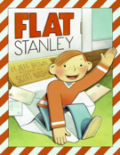
On the next page you will find a sample entry to show the format of writing the journals should contain.
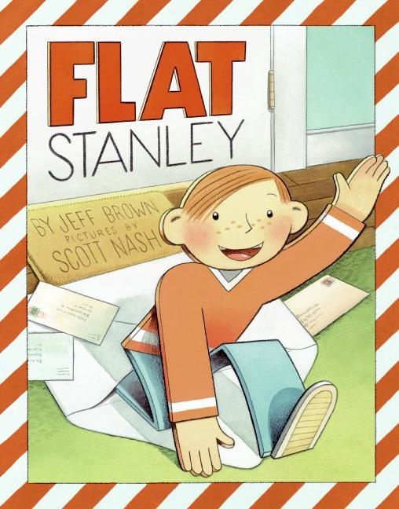
(Topic Sentence) Today I reached new heights, I visited the amazing Space Needle in Seattle, Washington. (Descriptive sentences-at least 3 are required, but I included more) First, we boarded the elevator and received a quick, but educational overview by our guide. The tour guide was as factual as an atlas. (Simile) Did you know the Space Needle was built in 1962 and is 605 ft. tall? Next, we wandered around the visitor center. It was great because you could learn all about Seattle, and use the cool technology they have added. Finally, we went out on the observation deck. What a view! The wind was howling. (Personification) (Conclusion) I can’t wait to go back to the Space Needle again. Next time I might eat dinner in the revolving restaurant.

Minimum for journal entries is 5 quality sentences.
- Topic sentence
- Three-five descriptive sentences of the event or place visited.
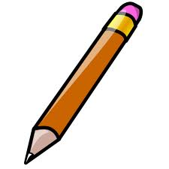
- Conclusion/wrap up sentence. Not just, “Bye, see you next time” It should wrap up the specific event you just described.
- Watch word choice and make sure words like “then” or “nice” are not used too often. Students should be using interesting, descriptive adjectives and adverbs throughout the journal.

